Screening, Brief Intervention, and Referral to Treatment (SBIRT) Training
www.sbirtfaithandspirituality.org
What is SBIRT?
SBIRT stands for Screening, Brief Intervention, and Referral to Treatment. It is a three-step process for identifying unhealthy substance use and addressing these issues by offering a brief intervention and/or referring them to treatment. The components of SBIRT are:
- Screening identifies people with potential substance use disorders (alcohol or other drugs).
- Brief Intervention is provided when the screening indicates moderate or high risk for a disorder. Brief Intervention utilizes motivational interviewing techniques focused on motivating people toward positive behavioral change.
- Referral to Treatment provides a referral to specialty care for persons deemed to be at moderate or high risk for a substance use disorder.
What is SBIRT Training?
The SBIRT Online Student Training offers an interactive and comprehensive look at substance use disorders, the three steps of SBIRT practice, and faith integration within SBIRT. It is a 4-hour training (you can stop and resume at any point) and contains 6 Modules:
- Module 1: Epidemiology and Science of Substance Use Disorders (SUDs)
- Module 2: Introducing SBIRT in Allied Healthcare Fields
- Module 3: Screening Tools for SUDs
- Module 4: Brief Intervention Practice for SUDs
- Module 5: Referral to Treatment for SUDs
- Module 6: Ethical Practice Guidelines and Special Cultural Considerations
Why take SBIRT Training?
- It is a National Priority: Substance use is a major public health issue and SBIRT has been endorsed as a national priority and is reimbursable under Medicaid and the Affordable Care Act (ACA).
- It is Required for Providing SBIRT Services: California State requires that all practitioners receive 4-hours of SBIRT training in order to bill for SBIRT services. This training meets this 4-hour requirement.
- You Receive a Certificate: Upon completion of the training, students will receive a Certificate of Completion, which will allow you to practice SBIRT in certain settings.
- It Looks Good on Your Resume: You can put it on your resume or graduate/professional application.
How to Access SBIRT Training:
- Type in this URL to access the training website: www.sbirtfaithandspirituality.org
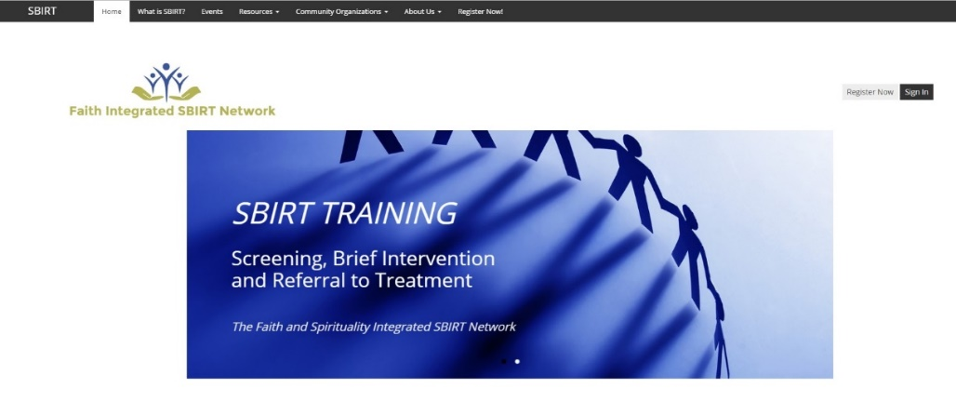
- Click on the “Register Now” button on the top right corner of the page. Complete the registration process.
- Fill out the Pre-Assessment Questionnaire (this will automatically appear once you finish registering).
- Click on the “Modules” tab to access the training. You much complete the Modules consecutively and pass a quiz at the end of each Module in order to move onto the next.
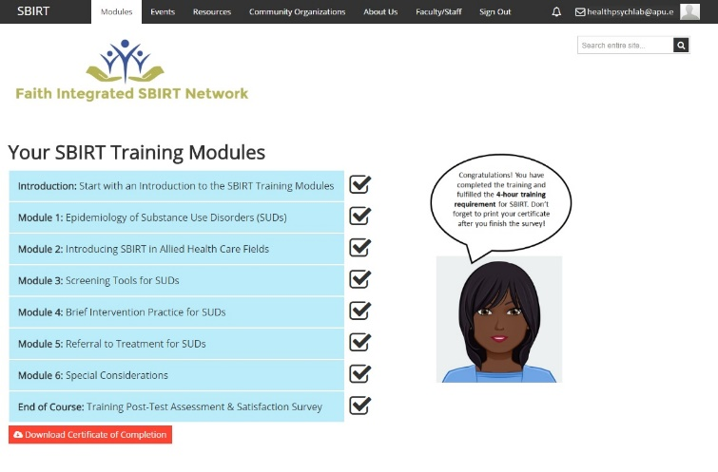
- Complete the 6 Modules and the Post-Assessment Questionnaire. Upon completion, you will be able to download your Certificate of Completion. You may come back and download the Certificate again at any time in the future.
- Click on the “Resources” tab to explore available resources and download practice materials.
- 30-Days after completing the training, you will receive a 30-Day follow-up Questionnaire for you to complete. It is very important that you do this.
Tips and Help:
- The Modules are accessible on computers and mobile devices, however for the optimal user experience, use an up-to-date computer browser (not Internet Explorer).
- For technical assistance, please email healthpsychlab@apu.edu or click on the “Contact Support” tab on the bottom of the webpage.

